

**Urmia University**, Urmia- West Azerbaijan (my hometown), Iran

2007-2011, **Bachelor in Electrical Engineering**

GPA: 18.30/20 (**Ranked 1st** )

**Tehran University\*, Tehran, Iran**

2011-2014, **Master in Electrical Engineering**

GPA: 17.99/20

**Tehran University\*, Tehran, Iran**

2014-2021, **Researcher in Biomedical Engineering**

**HTW Berlin, Berlin, Germany**

2023-Now, **Scientific Assistant in Gesundheitstechnik**



**Researcher in Biomedical Engineering with spirit of an artist**

**Languages:**

Azerbaijani,

Turkish,

Persian,

English,

German (A2.1)

**Research Interests**

Embedded Programming

Computational Neuroscience

fNIRS, EEG, and HDDOT

Brain Computer Interface

IC Design

Bioinstrumentation

Modeling and Simulation

**Contact Info**

Hochschule für Technik und Wirtschaft (HTW) Berlin

**Address:**

Campus Wilhelminenhof

WH Gebäude C, Raum 548

Wilhelminenhofstraße 75A

HTW Berlin, 12459

Berlin, Germany

**Cell-Phone:**

+4915231434208

**Email:**

Hadi.Borj@HTW-Berlin.de

Edu.borjkhani@gmail.com

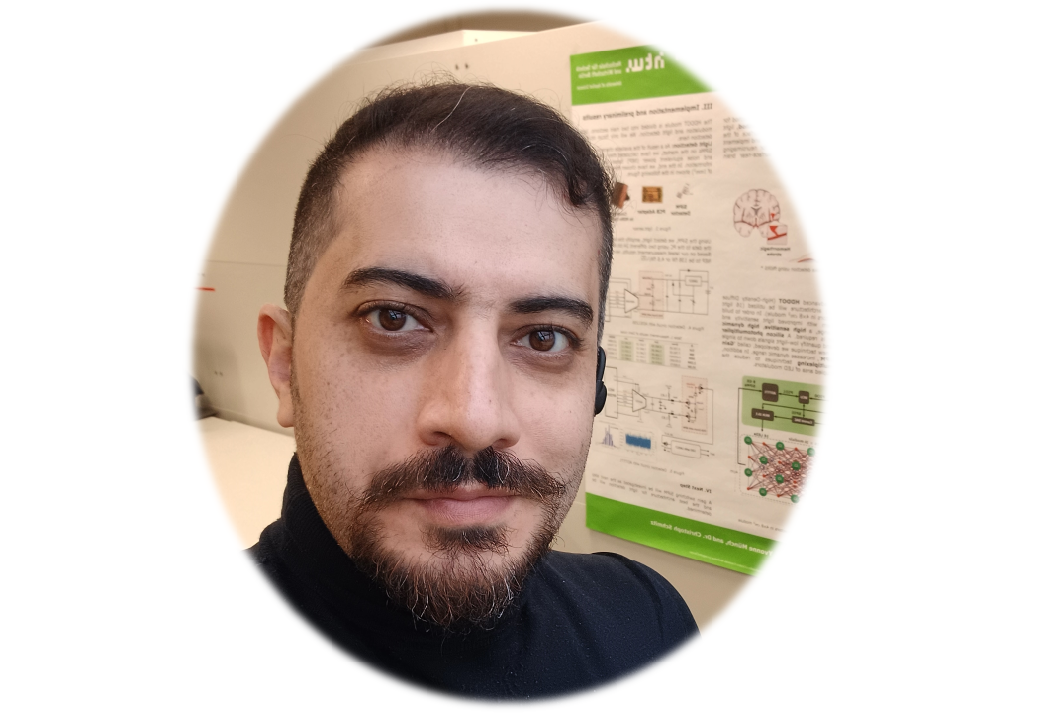

Hadi Borjkhani

Work Experience

**Scientific Assistant and Lecturer**

**2023-Now**

* HTW Berlin, Berlin, Germany

**Associate Researcher**

**2021-2023**

* Department of Psychological Science, Surrey, UK (Remotely)

**PhD Candidate**

**2014-2021**

* NIR Lab University of Tehran, Tehran, Iran

**Visiting Researcher**

**2018**

* Dipartimento di Fisica, Politecnico di Milano, Milan, Italy

**Guest Lecturer**

**2016-present**

* Urmia University of Technology, Urmia, Iran
* Science and Technology Institute, Urmia, Iran
* Urmia Graduate Institute, Urmia, Iran



Software and Hardware Skills

* **Electrical Circuit Simulation:** Cadence, ADS, Hspice, Proteus, and LTSpice
* **Mathematic Tools:** MATLAB and Python
* **Toolbox:** MNE, Brain AnalyzIR, ICAlab, EEGlab, EEGNet (CNN), Homer3, AtlasViewerGUI
* **Multiphysics Simulation:** COMSOL , COMSOL and MATLAB Live Link
* **Programming:** C, C++, MATLAB, Python
* **3D Printing and Laser-Cut:** CorelDraw, OpenSCAD
* **Experience with:** Ubuntu and Anaconda
* **Embedded Systems Programming:** Arduino IDE, VSCode (C)
* **Microcontrollers:** Arduino, Raspberry Pi, RP2040, and STM32
* **PCB Design:** KiCAD
* **Project Management:** Git, Github, Gitlab, OneNote, and Zenkit

**Academic Education in detail**

**Scientific Assistant in Gesundheitstechnik**

**University:** University of Applied Science Berlin, Berlin, Germany (July 2023- Now)

**Researcher in Biomedical Engineering (Bio-electric)**

**University:** College of Engineering, School of Electrical and Computer Engineering, Tehran University, Tehran, Iran (Sept. 2014 – Sept 2021).

**Head of Project: Prof. Dr. Seyed Kamaledin Setarehdan**

**Guest Researcher:** Dipartimento di Fisica, Politecnico di Milano, Milan, Italy (Feb 2018-August 2018).

**Supervisor in Politecnico di Milano: Prof. Dr. Alessandro Torricelli**.

Research focus: Processing the Signal of Overlapped Channels of functional Near-Infrared Spectroscopy (fNIRS) to improve the Spatial Resolution of Brain Mapping.

**Master of Science in Electrical Engineering (Circuit and System)**

**University:** College of Engineering, School of Electrical and Computer Engineering, Tehran University, Tehran, Iran (Sep. 2011-Aug. 2014).

**Supervisor: Prof. Dr. Samad Sheikhaei**

**GPA**: 17.99 out of 20

**Thesis title:** Design and Simulation of a Low Power BFSK/OOK MICS Band Transmitter for Biomedical Sensor Nodes

**Bachelor of Science in Electrical Engineering**

**University:** College of Engineering, School of Electrical and Computer Engineering, Urmia University. Urmia, Iran (Sep. 2007-Jul. 2011).

**GPA:** 18.30 out of 20. **Ranked 1st** among All Electrical Engineering students.

**Thesis:** Image and Acoustic Signal Processing, Using ICA (Independent Component Analyze) Algorithm.

**Honors and Awards**

* Scholarship for PhD study in HTW Berlin, Berlin, Germany.
* **Selected as an Exceptional Talented student** to continue in M.Sc. In Electrical Engineering without Entrance Exam at Urmia University and Tarbiat Modarres University.
* All levels of Education were **free in Government Supported Universities and Schools**.
* **Ranked 1st among All B.Sc.** students in Electrical Engineering, Urmia University 2011.
* **Won the 2nd prize** of Best poster award of **BCNC-2018**
* Selected as the **top graduate** by the Presidential Institution

**Publications**

**Preprints**

1. **Yücel, M. A., Luke, R., Mesquita, R. C., von Lühmann, A., Mehler, D. M. A., Lührs, M., Borjkhani H … Zemanek, V. (2024, September 24).** The fNIRS Reproducibility Study Hub (FRESH): Exploring Variability and Enhancing Transparency in fNIRS Neuroimaging Research. https://doi.org/10.31222/osf.io/pc6x8

**Journals:**

1. Borjkhani, Hadi, Seyed kamaledin Setarehdan. "**Quantitative Comparison of Analytical solution and Finite Element Method for investigation of Near-Infrared Light Propagation in Brain Tissue Model**." BCN 2021. **Accepted in Press**
2. Borjkhani, Hadi, Seyed kamaledin Setarehdan, Samad Sheikhaei. "**Optimal Sub-Harmonic Injection Locked MICS Band Transmitter for Wireless CW-fNIRS Systems.**" IJCTA 2021.
3. Borjkhani, Hadi, and Seyed Kamaledin Setarehdan. "**Performance assessment of high-density diffuse optical topography regarding source-detector array topology.**" *PloS one* 15.3 (2020): e0230206.
4. Borjkhani, Hadi, Mehdi Borjkhani, and Morteza A Sharif. "**Investigating the Cocaine-induced Reduction of Potassium Current on the Generation of Action Potentials Using a Computational Model." *Basic and Clinical Neuroscience***: (BCN 2022).
5. Borjkhani, H., S. Sheikhaei, and M. Borjkhani. "**Low power MICS band Transmitter for Bio-Medical Sensor Nodes with Driving Capability by Energy Harvesting Systems**." *Iranian Journal of Biomedical Engineering* 8 (2014): 31-43.
6. Fathizadeh, Samira, Sohrab Behnia, F. Nemati, Mostafa Salimi, and Hadi Borjkhani. "**Chaotic control of the dynamical behavior of COVID-19 through the electromagnetic fields**." *Physica Scripta* (2022).

**Conferences:**

1. Borjkhani, Hadi, Samad Sheikhaei, and Mehdi Borjkhani. "**Low power current starved sub-harmonic injection-locked ring oscillator**." *2014 22nd Iranian Conference on Electrical Engineering (ICEE)*. IEEE, 2014.
2. Borjkhani, Hadi, Mehdi Borjkhani, and Samad Sheikhaei. "**A 168µW MICS band transmitter based on injection locking for biomedical sensor nodes**." *2013 20th Iranian Conference on Biomedical Engineering (ICBME)*. IEEE, 2013.
3. *"***Modeling and Simulation of Near-Infrared Light Reflectance from Brain Tissue Using Perturbation Theory***"* Hadi Borjkhani, Seyed kamaledin Setarehdan, BCNC-2018. **Poster (Won the 2nd prize of the best poster award)**
4. *"***Comprehensive Approach for Synthetic fNIRS Data Generation***"* Hadi Borjkhani, Seyed kamaledin Setarehdan, BCNC-2018. **Oral**
5. Soltanlou, Mojtaba\* (University of Surrey, UK); Borjkhani, Hadi (University of Tehran, Iran); Nuerk,

Hans-Christoph (University of Tuebingen, Germany) **“Arithmetic training improves neural functionality in children with dyscalculia”** *Mathematical Cognition and Learning Society Conference* (MCLS2022)

**Posters:**

Forschungsforum 2024

Jahrestag 2025

**Research interests with experience**

* **Mathematics and Physics**
* **Programming with** C/C++, MATLAB (professional), Python (Keras, TensorFlow, NumPy, Matplotlib, Pandas,..)
* **Digital Signal Processing (DSP) using MATLAB/Python**
  + **fNIRS/EEG signal processing using MNE-Python (**Raw, Epochs, Evoked, SourceEstimate, SSP, Artifact removal, PSD, FFT, SSR, Inverse problem, Mapping, …**), MATLAB (**EEGLab, FieldTrip, and BrainAnalyzIR)
  + **EEG Pre/post-processing and Visualization in Python/MATLAB**
  + **BCI with EEG** signals and Convolutional Neural Networks (CNNs)
* **Modeling and Simulation**
  + **Multiphysic simulation using COMSOL and COMSOL and MATLAB Live-Link**
  + **Simulation and modeling for fNIRS, DOT, and HDDOT** systems to produce synthetic signals, calculate Jacobian matrix, depth sensitivity analysis, performance assessment of optodes arrangement, or inverse problem
  + **Computational Modeling of Neurons** in MATLAB and Python
  + **Modeling and Simulation of Acoustic Wave Propagation in Tissue Model Using FEM Methods** (Single piezo-electric or phased array)
* **Integrated/discrete circuit design and simulation using CAD Tools**
* **Bioinstrumentation (ECG, EEG, NIRS, and …)**
  + **Hardware design and implementation** with signal acquisition and interface with PC using Developed GUIs in MATLAB and Python
  + **3D design for printers**
  + **Microcontrollers: Arduino, Raspberry Pi, STM32**
* **Image processing, reconstruction, and mapping** in anatomical or simple head models using fNIRS, DOT, HDDOT
* **System Identification**, **Pattern Recognition**, and **Machine Learning**
* **Low power RF transmitter** design and simulationin 0.18 $μm$ CMOS technology
* **Project Management: Gitlab, Zenkit, OneNote**

**System Design and Implementation**

16-24 Channels **Near-Infrared Spectroscopy (NIRS) System** for Light Propagation Study in Tissue

**Heart-Rate Variability (HRV)** Analyzer

2-Axis **CNC System** and **Syringe Pump**

**ADC and DDC reading with Raspberry Pi using SPI** for optical sensor experiments

**Optical Sensors (PD or SiPM) noise measurement with DDC and ADC**

**ADC Driving: ADS1256 and AD7771 driver for the first time in world for RP2040**

**DAC Driving: AFE532A3W for RP2040 for the first time in world**

**Teaching experience as Lecturer for undergraduate students in HTW Berlin**

**Gesundheitstechnik** Project, Winter 2023, HTW Berlin

**Medical Sensors and Measurement Technology Lab**, Summer 2024, HTW Berlin

. **Electrical Engineering Lab,** Winter 2024, HTW Berlin

**Analog Electronic Lab,** Winter 2024, HTW Berlin

**Co-Supervising of the Bachelor Thesis**

F. L. Arndt, "Entwicklung einer leistungsfähigen ultrakompakten Viel-Kanal-LED-Ansteuerung für ein tragbares fNIRS-System," Bachelor's thesis, Hochschule für Technik und Wirtschaft Berlin, Berlin, Germany, Sept. 2024.

**Teaching experience as guest Lecturer for undergraduate and graduate students**

**Anatomy & Physiology** : since 2021

**Biophysics** : since 2021

**Medical Imaging** : since 2021

**Rehabilitation** : since 2021

**Telemedicine** : since 2021

**Bioelectric Phenomena** : since 2021

**Engineering Mathematics**: since 2016

**Electronic I** : 2019

**Communication Circuits** : 2017

**C++ Programming** : 2016

**Artificial Neural Networks** : 2016 – Graduate

**Accredited graduate courses**

**Medical Instruments**

**DSP (Digital Signal Processing)**

**System Identification**

**Dynamic Systems in Neuroscience**

**Pattern Recognition**

**Medical Ultrasound**

**Anatomy and Physiology**

**RFIC (Radio Frequency Integrated Circuits)**

**VLSI (Very Large Scale Integrated Circuits)**

**Analog Integrated Circuits**

**ADC (Analog to Digital Converters)**

**HSSL (High Speed Serial Link)**

**Large Area Electronic**

**SOI (Silicon On Insulator)**

**References**

1. **Prof. Dr. Seyed Kamaledin Setaredan** ([ksetareh@ut.ac.ir](mailto:ksetareh@ut.ac.ir))  
   Professor of Electrical and Computer Engineering,  
   Director of Optics in Medicine and NIR laboratories,  
   School of  Electrical and Computer Engineering,  
   College of Engineering,  
   University of Tehran, P.O.Box 14395/515  
   Tehran, IRAN  
   TEL: 0098-21-6111 4177  
   Fax: 0098-21-8863 3029  
   Mobile: 0098-912-1949264
2. **Prof. Dr. Mehdi Eskandarzade (**[m.eskandarzade@uma.ac.ir](mailto:m.eskandarzade@uma.ac.ir))

Assistant Professor Department of Mechanical Engineering

[University of Mohaghegh Ardabili](https://scholar.google.com/citations?view_op=view_org&hl=en&org=17556002772160524817)

Ardabil, Iran

Phone: +98 914 354 1326

1. **Prof. Dr. Morteza A. Sharif** (m\_a\_sharif@hotmail.com)

Assistant Professor Electrical Engineering Department,

Urmia University of Technology,

Urmia, Iran

Phone: +98-914-3458471

1. **Prof. Dr. Mehdi Borjkhani** ([mborjkhani@ichf.edu.pl](mailto:mborjkhani@ichf.edu.pl))

Assistant Professor Institute of Physical Chemistry,

Polish Academy of Sciences

Warsaw, Poland

Phone: +48-577-065980

1. **Prof. Dr. Mojtaba Soltanlou** ([m.soltanlou@surrey.ac.uk](mailto:m.soltanlou@surrey.ac.uk))

Assistant Professor in Developmental Cognitive Neuroscience

Department of Psychological Science

Room: 16 AC 05

University of Surrey

Guildford, Surrey

GU2 7XH, UK

T: +44 (0)1483 684195

**Current Projects**

1. **Visualization of fNIRS ttest values on Brain Atlas**

**Contribution:** 100%

**Application:** Cognitive Neuroscience

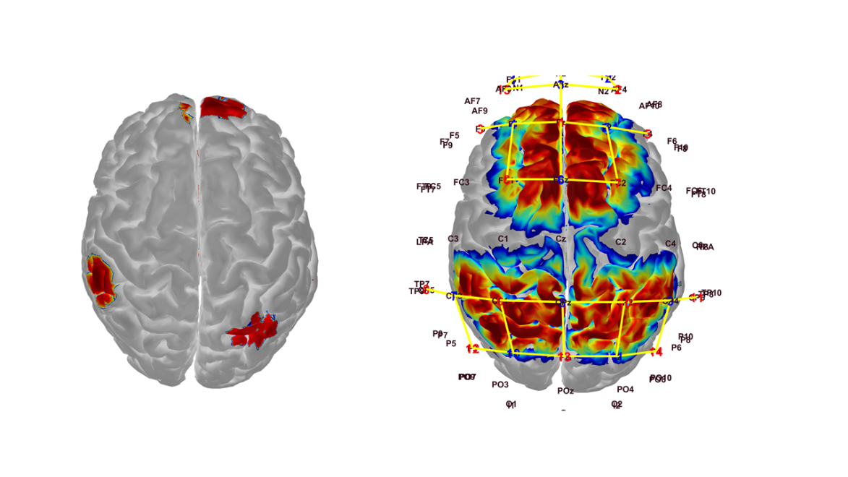

1. **fNIRS Signal Analysis for 42 subjects (South Africa data)**

**Contribution:** 100%

**Application:** Cognitive Neuroscience

**Team Head:** Mojtaba Soltanlou



**3-**

**Accomplished Projects**

1. **Heart Rate Variability (HRV) Analyzer: 2017-2018**

**Contribution:** 100%

**Application:** Quantitative stress level assessment

**Team members:** Mehdi Borjkhani, Morteza A. Sharif

**Publish status:** Not yet

In this project, I have designed and implemented a three lead ECG hardware to study heart rate variability.

For fast data acquisition, I use MegunoLINK. The MATLAB environment is used for pre-processing of the ECG and calculation of the RR intervals. The time-domain, nonlinear results, and frequency-domain analysis applied for the RR time series using Kubios software.

D:\PostDoc\Golden CV\Project_ECG.tif

Figure 1: (a) Hardware and software for ECG signal acquisition and processing (b) The sample output for one subject

1. **Developing the NIRS system: 2016-present**

**Contribution:** 100% (related to my PhD thesis)

**Applications:** Near-Infrared Spectroscopy; Image mapping based on processing of the raw reflectance to achieve optical density (OD); Synthetic fNIRS data generation in liquid phantom by using syringe pump and balloon; Optical channel’s sensitivity measurement.

**Team member:** Seyed Kamaledin Setarehdan

**Publish status:** Not yet

I have designed and implemented this system myself with minor supervision. It was a part of my PhD thesis. The NIRS system contains, main system, laser diodes, laser coupler, optical fibers, optical detectors, a probe (to fix the optodes), CNC (to move perturbation in liquid phantom), syringe pump (to produce dynamic perturbation), liquid phantom with similar absorption and scattering coefficient of the body.

The graphical abstract of the outputs of the system can be found below (Fig 2):

D:\PostDoc\Golden CV\Projects_NIRS.tif

Figure 2: (a) Main system with CNC, syringe pump, and liquid phantom. (b) same system from other view (c) application of the system in image mapping, synthetic hemodynamic generation, sensitivity measurement for optical channels.

1. **Investigating the effect of large-scale fNIRS channels on spatial image resolution: 2019-present**

**Contribution:** 100% (related to my PhD thesis)

**Applications:** fNIRS, DOT, and HDDOT modeling and simulation

**Team member:** Seyed Kamaledin Setarehdan

**Software:** MATLAB and COMSOL

**Publish status:** Not yet

I have made a simulation setup on COMSOL for light propagation in head tissue models. This setup has a lot of application such as investigating the effect of large-scale fNIRS channels on spatial image resolution. You can see two different channel’s arrangement, HDDOT and MDMD. I’ve used analytical and numerical methods to compare the effect of these two arrangement on spatial resolution of the image.

E:\Plos_One_Rubut_2021\PLosOne Rebutal\Figures\Two Model and Channels Arrangement.tif

Figure 3: (a) HDDOT optodes arrangement. (b) HDDOT channel’s distribution. (c) MDMD optodes arrangement. (d) MDMD channel’s distribution. (e) The block diagram of the analytical and hybrid model

E:\Plos_One_Rubut_2021\PLosOne Rebutal\Figures\Fig 1 - Repreantation of Simulation.tif

Figure 4: Numerical simulation setup using COMSOL and MATLAB (a) geometry in COMSOL. (b) Developed algorithm in MATLAB. (c) Cerebral and extra-cerebral hemodynamic pattern. (d) A sample of steady state study of light propagation from source into multilayered slab geometry.

The outcome of those modelling and simulations:

The resolution parameter (RP) improved by using MDMD arrangement. In two different depth we have calculated the RP, and singular value for HDDOT and MDMD configurations.

E:\PhD Thesis\Hybrid_Model_April_18_2021\FEM Forward Model\Results\RP.tif

Figure 4: (a) RP for different perturbation distance for HDDOT and MDMD under -15mm depth. (b) Same as (a) but the perturbations depth is -25mm. (c) SVD analysis for both arrangements.

1. **Performance assessment of optodes arrangement on spatial resolution:**

**Time Interval: 2018-2021** (related to my PhD thesis)

**Contribution:** 90%

**Applications:** Modeling and simulation of light propagation in brain tissue model; optimization and performance assessment of the inverse problem and optodes arrangement.

**Software: MATLAB**

**Publish status:** PlosOne-2021

**Head of the project:** Seyed Kamaledin Setarehdan, Tehran, Iran

1. **Robot control based on EEG data :**

**Time Interval: 2020-2022**

**Contribution:** 70%

**Applications:** Brain-computer interface (BCI), Rehabilitation

**Duty:** Signal processing andclassification

**Software: Python**

**Classification accuracy of EEGNet (Fig. 5):** 100% for synthetic data, 60-80% for real recorded data

**Publication is not allowed:** I did this project for a private company

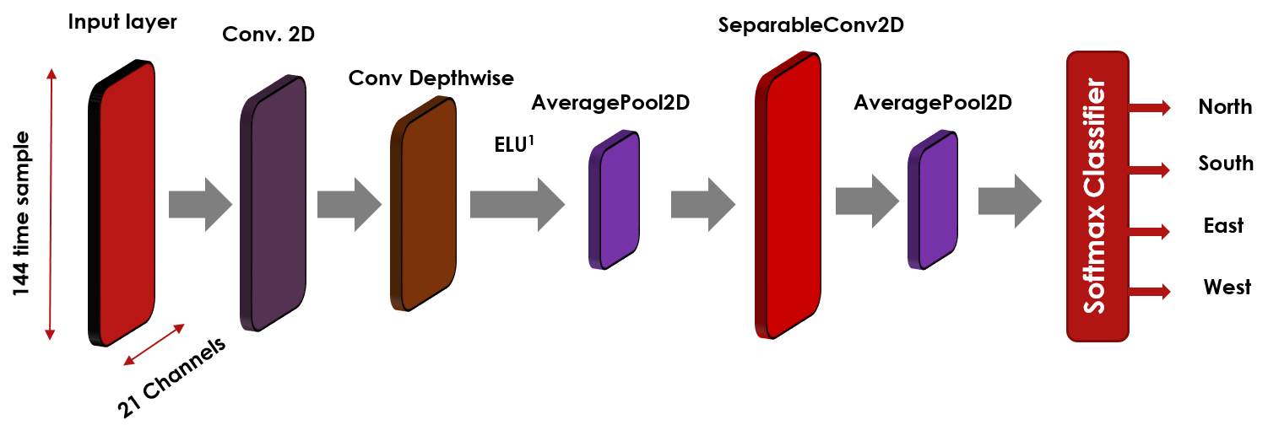

Figure 5: EEGNet (a Convolutional Neural Network)

1. **ERS/D calculation of EEG channels: 2021-present**

**Time Interval: 2021-present**

**Contribution:** 80%

**Applications:** [Arithmetic training improves neural functionality in children with dyscalculia](https://scholar.google.com/citations?view_op=view_citation&hl=en&user=yuHq5nwAAAAJ&citation_for_view=yuHq5nwAAAAJ:LkGwnXOMwfcC)

**Duty:** Signal processing andERSD calculation from raw data

**Software: MNE-Python and MTALAB**

**Publish status: MCLS 2022**

**Head of the project:** Mojtaba Soltanlou, Surrey, UK

**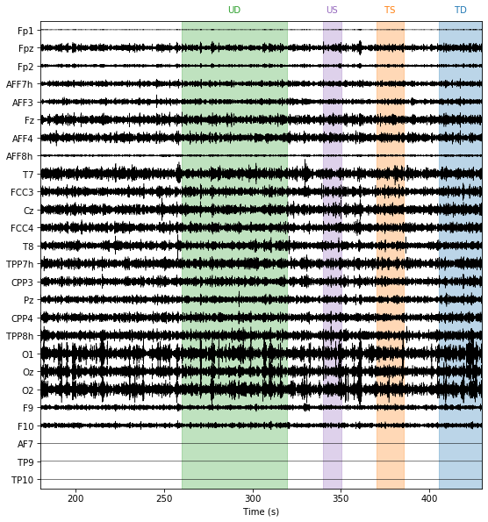**

Figure 6: 24 Channels EEG data after processing. Annotations are based on the difficulty of the tasks

1. **Neuron modeling and simulation in cellular level**

**Time Interval: 2020-2022**

**Contribution:** 50%

**Applications:** Computational neuroscience

**Duty:** Modeling and simulation of neuron model; Visualization

**Software:** **MATLAB**

**Publish status:** Not yet

**Head of the project:** Mehdi Borjkhani, ICTER, Poland

**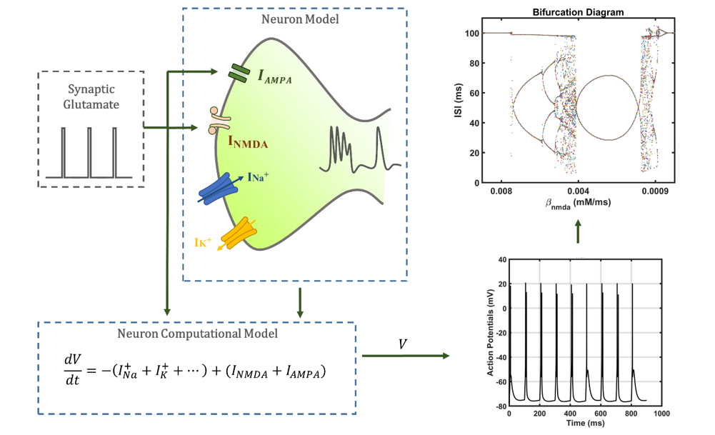**

Figure 7: Bifurcation diagram for a single spiking neuron model by modulation of $β_{NMDA}$

1. **RF transmitter and Oscillator design and simulation using injection locking**

**Time Interval: 2011-2021**

**Contribution:** 100%

**Applications:** Wireless biosensors, Analog circuits

**Software:** **ADS and MATLAB**

**Publish status: IJCTA 2021, ICEE2014, IJBME 2014, ICBME 2013**

**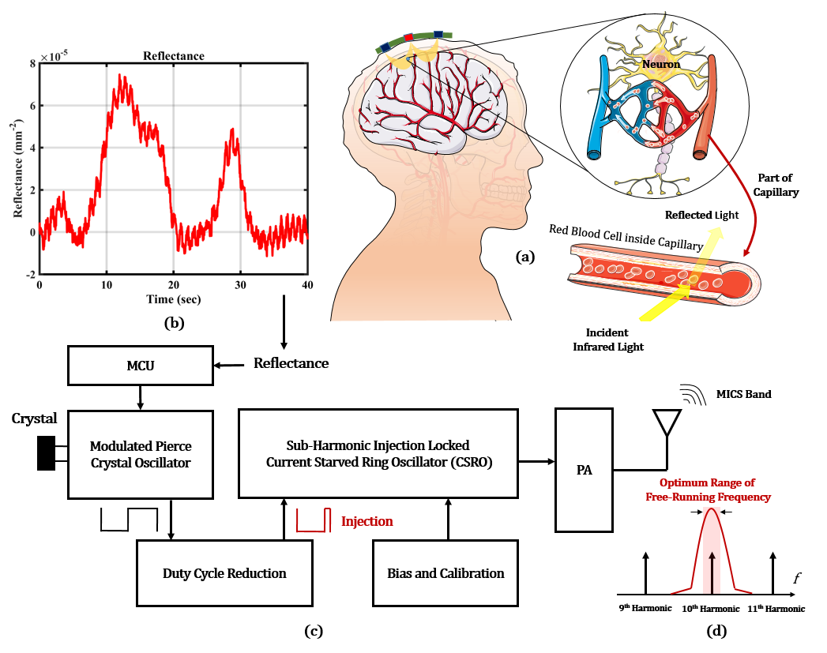**

Figure 8: Low power RF transmitter designed and simulated in 0.18um technology

1. **Ring-oscillator based neuron model**

**Time Interval: 2017-present**

**Contribution:** 100%

**Applications:** Neuromorphic engineering

**Software:** **ADS and MATLAB**

**Publish status: Not yet, Preliminary study**

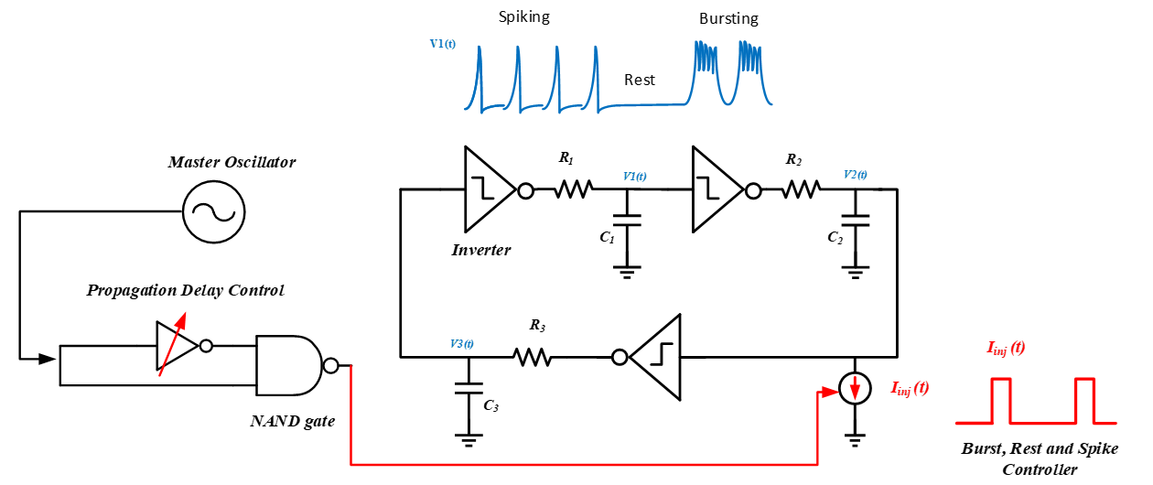

Figure 8: Robust neuron model designed for neuromorphic applications

1. **FRESH Project**

**Time Interval: 2022-2023**

**Contribution:** 100%

**Applications:** fNIRS signal Processing

**Software:** **Python and MATLAB using MNE and Nirstoolbox (Brain AnalyzIR)**

**Selected projects in graduate courses:**

1. **Modeling and simulation of acoustic wave propagation in tissue model:** I’ve accredited to a graduate course entitled “Medical Ultrasound” and I made a simulation setup in COMSOL using three different physics to simulate acoustic wave propagation in different angles using phase array piezoelectric by stimulating them with Gaussian electrical pulses with tuned delay. I also recovered the reflected waves (detected by piezo) in A-mode scanning to estimate the position of the abnormality in tissue model.
2. **System Identification of steam generator by supervised learning:** based on the input and output of the steam generator, I have trained and tested the LSSVM (Least Square Support Vector Machine) algorithm to identify a nonlinear system behavior.
3. **Pattern Recognition of segmented image based on the dataset of Vision Group, University of Massachusetts:** The image data classified into seven class with very good accuracy. The statistical method for evaluation of the performance was confusion matrix.
4. **Design and Simulation of integrated circuits related to my mater courses:** 12 bit pipeline ADC, Oscillators (of any kind), operational trans-impedance amplifiers (OTA), band-gap reference (BGR), and logic gates.